Five Channel Video Installation
13 Minutes, 27 Seconds.
Deluge is a culmination of Mendel’s ten years of work on the Drowning World project, shooting video and stills in thirteen different countries. It depicts a variety of individual stories, positioned with a synchronous global narrative in a way that is both personally intimate and deeply political. In all his years of responding to floods and making many journeys he has shot a vast archive of video footage, which is fully activated in this presentation for the first time.
About Gideon Mendel and his Drowning World project:
Gideon Mendel came of age as a photographer in South Africa in the 1980’s and identified strongly as a ‘struggle photographer’. This marked him and his subsequent career has been notable for his engagement with three of the crucial political and social issues that have faced his generation. These are the struggle against apartheid, HIV/AIDS in Africa and Climate Change.
A leading contemporary photographer, Gideon Mendel's intimate style of image making and long-term commitment to projects has earned him international recognition and many awards. He was shortlisted for the Prix Pictet Prize 2015 and recently has won both the inaugural Jackson Pollock Prize for Creativity and the Greenpeace Photo Award 2016.
His on-going project ‘Drowning World, explores the human dimension of climate change by focusing on floods across geographical and cultural boundaries. By highlighting the personal impact of flooding he evokes our vulnerability to global warming questioning our sense of stability in the world.
The work began in 2007, when Mendel photographed floods in the UK and in India within weeks of each other. He was deeply struck by the contrasting impact of these events, and the shared experiences of those affected.
Since then he has endeavoured to travel to flood zones around the world visiting Haiti (2008), Pakistan (2010), Australia (2011), Thailand (2011), Nigeria (2012), Germany (2013), The Philippines (2013), The UK (2014), India (2014), Brazil (2015), Bangladesh (2015), the USA (2015 and 2017) and France (2016 and 2018).
As the work progressed photographing floods became both a literal and allegorical means of documenting the tension between the personal and the global effects of climate change. Each location added has intensified the narrative impact of the endeavour.
Drowning World now consists of four parallel and connected narrative elements: Submerged Portraits, Flood Lines, Watermarks, and Deluge.
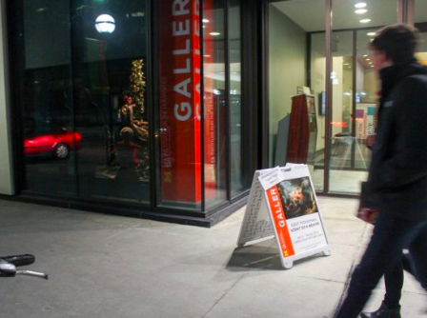
N. University Avenue
S. Thayer Street
State Street
Deluge Exhibit
is here
E. Washington Street

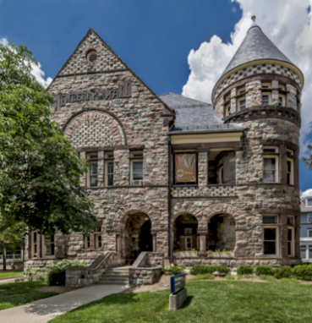
The Kelsey Museum of Archaeology supports teaching and research on Classical, Egyptian, and Near Eastern archaeology through stewardship of its rich collections, an active exhibitions program, and sponsorship of ongoing field research. The Kelsey houses a collection of more than 100,000 artifacts, of which approximately 1,500 are on permanent display; in addition, the Museum mounts 2-3 special exhibitions annually. As an exhibit museum at a public university, the Kelsey embraces a vigorous public outreach mission, engaging with local residents and visitors of all ages, from kindergarten through retirement. It also serves as the headquarters of the University of Michigan’s graduate program in Classical Art and Archaeology.

Construction Updates near the Kelsey Museum: Public: The public entrance is on Maynard Street.

Special Exhibition on View: Urban Biographies, Ancient and Modern
“Human beings are by nature political animals.” The Greek philosopher Aristotle wrote these words over two thousand years ago, but they remain true today. We are still political animals — animals that live in the polis, the Greek word for “city” — and just as we still read Aristotle, so are we still fascinated by the cities of ancient Greece and Rome.
Archaeologists have always been interested in how urban centers grow and change over time. In the past, the sheer size of archaeological sites and the cost of excavation forced scholars to limit their research to small areas. Today, new technologies such as aerial mapping and subsurface sensing allow archaeologists to see entire urban landscapes in high resolution. This broader perspective enables researchers to go beyond broad generalizations and to recreate detailed biographies of individual ancient cities.
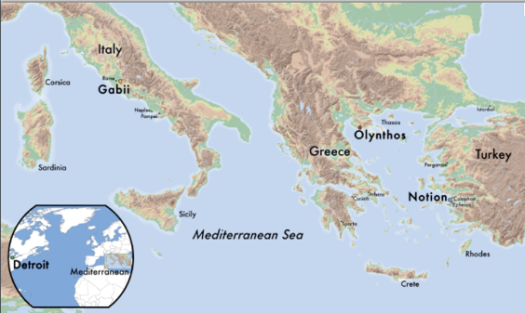
This exhibition, on view at the Kelsey Museum of Archaeology from August 24, 2018 to January 6, 2019, showcases three ancient cities currently being studied by Kelsey archaeologists — Gabii in Italy, Olynthos in Greece, and Notion in Turkey — and compares them with modern Detroit in the USA, focusing on urban rebuilding projects. What do the biographies of these ancient urban centers reveal about how their citizens responded to stress and change? What can we learn from the choices they made, and how can we apply those lessons to understanding a 21st-century city?
One of the challenges facing modern cities such as Detroit is the power of entrenched ideas about what is “normal” and “appropriate” for cities. A historical perspective, which draws attention to the fact that cities in different times and places have often developed along very different lines, can help to liberate contemporary urban planners and citizens to imagine alternative futures for their communities. In addition, modern techniques of archaeological investigation, such as the study of soil stratification or the analysis of satellite imagery, may provide fresh approaches to issues addressed by contemporary planners and thinkers. Join archaeologists, architects, urban planners, and citizens as we explore cities of the past, present, and future, asking the following questions:
State Street
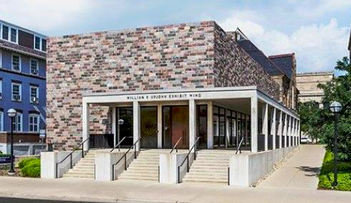
Construction Entrance:
Walk from State Street to the left of the building- this will lead you to the Maynard Street entrance.
Maynard Street

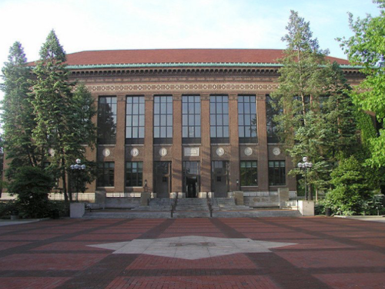

This exhibit features works of Coptic literature from the U-M Library Special Collections Research Center. Preserved by the dry climate of the Egyptian desert (like so many other ancient artifacts), these manuscripts document the transmission of the literary heritage of Egyptian Christians, from its beginnings in the 4th century through the 13th centuries CE, when Coptic was superseded by Arabic. The exhibit explores the main Coptic dialects; bilingualism in Egypt; books read by the Egyptian monks; and the works of Shenoute the Great, the most important author of Coptic literature.

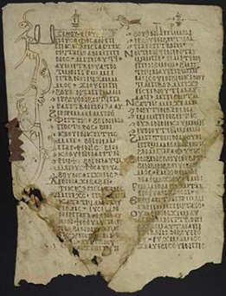
This exhibit is curated by Dr. Frank Feder and Dr. Alin Suciu from the Göttingen Academy of Sciences and Humanities. The exhibit and related programming are offered with support from the Department of Middle East Studies and the Kelsey Museum of Archaeology.

Coptic (noun) ~The language of the Copts, which represents the final stage of ancient Egyptian. It now survives only as the liturgical language of the Coptic Church.

Shenoute of Atripe (ca. 348-465). Content: Canon 7. Acephalos work A13: 79: i.1-ii.32. Is Ecclesiastes Not Wise: 80: i.2-ii.33. Parchment, 1 leaf, 380 x 288 mm. Verso. Origin: White Monastery (Atripe, Egypt). 8th AD.

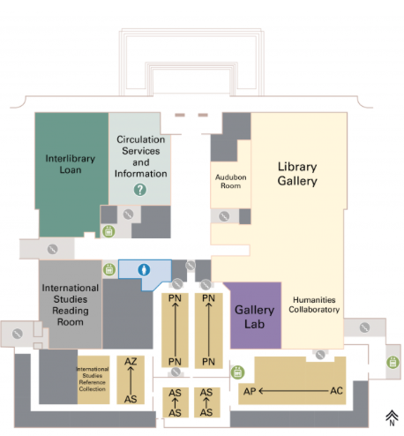
State Street
South University Avenue
Go up the stairs from Diag, then enter main doors. Audubon Room is the room on the left.

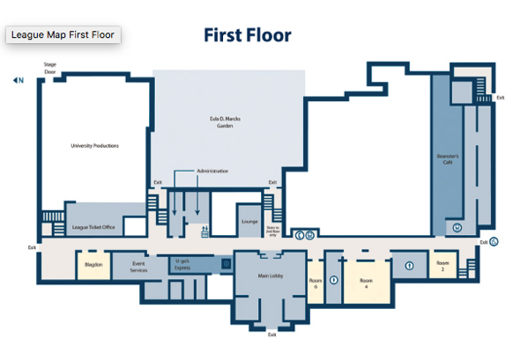
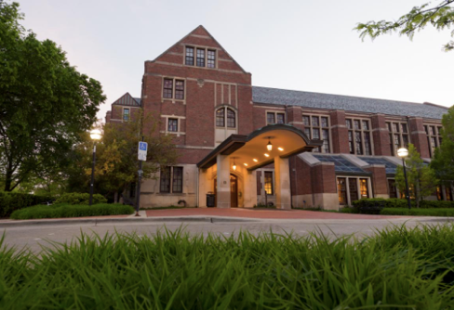
Rooms 2 & 4
North University

Thrift Shop with Students Helping Honduras!

Stop by Thrift SHHop in the Michigan League to support Students Helping Honduras! We will resell used clothing, shoes, and accessories at super cheap prices. All proceeds will go directly towards the construction of elementary schools in rural Honduran communities!
Students Helping Honduras (SHH) is a UM student organization which promotes education and youth empowerment in order to alleviate the burden of gang violence and extreme poverty among Honduran youth.

Students Helping Honduras (SHH) was founded in 2007 by a man named Shin Fujiyama. Since its founding, it has built 15 schools and counting in Honduras, the home of cities like San Pedro Sula, where the murder rate and gang populations are high enough to consistently make them front page news on the New York Times and other prestigious US news sources. In 2009, Mr. Fujiyama received a CNN Heroes award for his work in Honduras and appeared on shows like Larry King Live to explain the groundbreaking work Students Helping Honduras was facilitating in Honduras. SHH is only able to build schools and safe communities in Honduras through the fundraising and volunteering provided by collegiate chapters in the United States. The University of Michigan chapter of Students Helping Honduras looks to build a community of passionate, strong-willed University of Michigan students who can help (1) build knowledge and awareness of the University of Michigan campus of the current issues being faced by Honduras and, as a consequence, how those issues translate to current border disputes and international politics, (2) raise money to build schools and donate school supplies to the communities working with SHH in Honduras, and (3) send volunteers on a safe and empowering service trip to Honduras at least once per year to participate in the building of these schools and to learn about the culture and people of Honduras.
This organization hopes to build a movement of young UM leaders with the collective goal of empowering and providing fundamental human needs to impoverished children and familes in Honduras by promoting awareness through volunteerism and global responsibility.

