“I thought of Munch as I sketched, his theory that pain, love, and despair were links in an endless chain.” - Lina

Ruta Sepetys’ conscious choice to make Lina an artist and the inclusion of Edvard Munch and his work in Between Shades of Gray each have a profound impact on the novel. Why did Ruta Sepetys choose Edvard Munch’s artwork as Lina’s inspiration?

In a well thought-out, multi-paragraph response, explore why Ruta Sepetys chose to make Lina an artist and also include Edvard Munch as Lina’s inspiration.

Structure:

I. Introduction - Why is art important? What does art mean to you? How and why is it valuable?

II. How has Lina’s own art influenced her experiences since her family was taken prisoner? Use a specific example from Between Shades of Gray.

III. Choose a painting by Edvard Munch that is relevant to Between Shades of Gray and copy into your Google Doc. Next, describe your observations of the painting and what you think it means. Consider Munch’s background and influences as you interpret his painting. Reference the Munch PowerPoint images, quotations, and biographical details as needed. Don’t copy website interpretations of the painting.

IV. Introduce and examine a direct quote from Between Shades of Gray that specifically alludes to Munch and/or Munch’s paintings. Next, explain how Lina’s experience is connected to / affected by Munch’s artwork.

V. Conclusion - Ultimately, how does art and Munch impact Lina’s life? In your own life, who or what impacts you? Discuss how you express yourself in times of stress or when you face difficult situations. Consider the following questions as you draft your conclusion: Whose work, words, athleticism, or art offers you strength, hope, or an opportunity to reflect and focus? Do you have an important activity that provides an outlet when you need one?

By end of class today, complete Parts I and II. Revisit tomorrow and add Parts III, IV and V. Revise!
Submit your final draft at “Turn in Papers” on my website.

References to art / sketching in Between Shades of Gray are listed below.
Section I: Thieves and Prostitutes
3
8
18
22
35
37
52*
59
73
90-2

*Munch is mentioned **The Scream is mentioned
Section II:
Maps and Snakes
115-6
118
122
125-6
129
141
148
153
162-7
169-70
170
173
174
178*
193
197**
198
199**
211
213
215
226
230
244

Section III:
Ice and Ashes
248
284
295*
301
302
309*

173-4
178*
193
197**
198
199**
211
213
215
226
230
244

173
174
178*
193
197**
198
199**
211
213
215
226
230
244

Student Model: The Value of Art

Any form of art is a way for people to express themselves. Art is unique and will never be exactly the same for each person. For me, art is emotion made into a physical form. Things that I normally wouldn’t say out loud can be expressed through my artwork instead of bottling up emotions that would slowly tear me apart. With more products being mass produced by machines, uniqueness is being lost. Art is very valuable because it is one of a kind and handmade.
In Between Shades of Gray Lina uses art to help her remind her of herself and her surroundings, as well as keeping herself sane. When they are in one of their standoffs with the NKVD she uses what her previous art teacher has said, “if you breathed deeply and imagined something, you could be there. You could see it, feel it.” (164) She uses her extensive imagination to get herself to forget about the terrible events unfolding in front of her. She reasons if the NKVD soldiers aren’t there in front of her they don’t have any control over her. Lina uses what little downtime she gets to draw and write in her tablet about what is going on, who’s doing what and what their surroundings look like, in hopes of delivering them to her father or anyone that will help them.
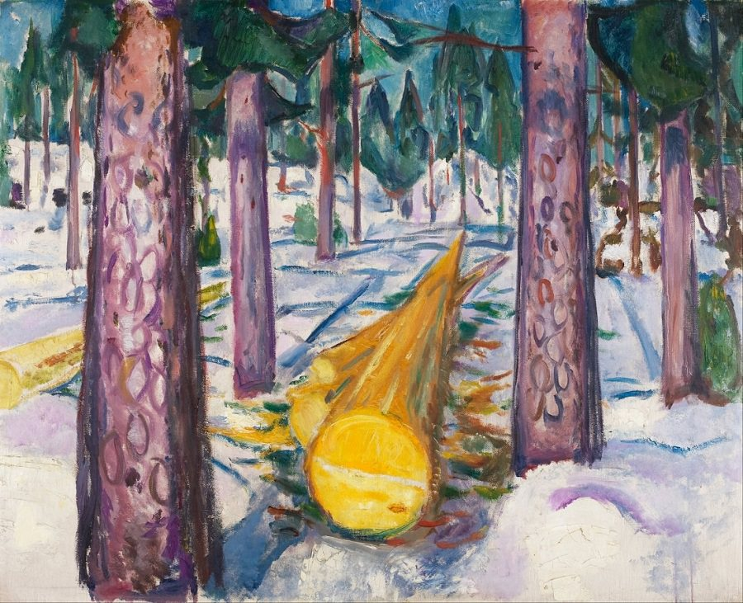
“Yellow Log” was painted in 1912 by Edvard Munch and it depicts fallen timber in a snow covered forest. The perspective Munch uses is very dramatic and emphasizes the length of the log. The yellow of the log contrasts the purple and green of the other trees that are standing. The landscape was probably influenced by his home country of Norway because of the spruce and snow covered ground. The yellow log in the painting could be interpreted as someone or something not fitting into their surroundings or standing out. Even further being, Munch himself not fitting in with his surroundings. His mental illnesses, like depression, would make it hard for people to understand his thinking and influenced this painting.

“But as soon as I saw photos of Anxiety, Despair, and The Scream, I had to see more. His works wrenched and distorted, as if painted through neurosis. I was fascinated.” (197) The passage from Between Shades of Gray specifically states 3 of Munch’s works. It also describes Munch’s artistic style and personality because of his mental illnesses. He is known as a painter with many of his works being dark and depressing. Lena immediately recognized the influence of his depressing work because of her knowledge in the arts. She can assume that Munch has mental health problems because a normally sane person won’t usually draw so distortedly.
Without art, Lena won’t have an outlet for her emotions throughout her life as she is forcefully taken away from home. Her art also connects her to her father who is separated from the rest of the family. It is a way of expressing herself uniquely, by only being connected to her life. Almost all of the time art is my outlet for my emotions, good or bad. Most of my inspiration comes from personal experience or role models. My favorite people to draw include Cara Delevingne, Jared Leto and P. Thompson. I also use music as an outlet for stress. I like to find songs that relate to my life through the lyrics in them. Music also gives me hope through the tough times when I need something that I can’t find anywhere else.

