2018 Seniors: Below are the links (and instructions) for the two senior surveys. You CAN take these on your phone but you must screen shot the finished page for the first survey and the second survey with your name on the screen. If you are doing these at a computer, print out the completed pages. Bring the screen shots, or the printed pages, with you on Friday, when you get your cap and gown.

First Survey: https://www.surveymonkey.com/r/Pioneerses2018
QR Code: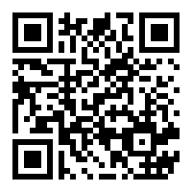

Second Survey
- Go to the Ann Arbor Public Schools Homepage – www.a2schools.org
- Select the Student/Families Tab and select student
- Find the Clever Icon and select it

  - OR follow this link: https://bit.ly/2sf4xnm
  - OR QR Code to connect to Clever

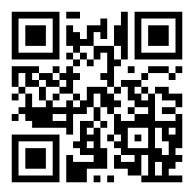
- Log into Clever with your Username: It should be the ID students use to access district computers, (Should be the beginning of the Google e-mail before the @ sign, for example 2018akinsconnie
- Password: Should be the default password provided at the beginning of the year on your student schedule (#Pio 1116, or Pio$116 or Com#1116) your birthdate the two digit month and day or default password
- Family Connections will allow you to complete the counselor assigned tasks for graduation.
- Click on the Planner Tab and Under Tasks Assigned to Me: Complete the Graduation Survey and Scholarship Search.

