Story #3: Interpreter of Maladies (pages 43-69) : Create a Travel Memoir
#Mr.Kapasi #DasFamilyVacation #InterpreterofMaladies #Secrets #Truth

This story is about an Indian-American family’s vacation to India, led by an Indian tour guide. Once you read the story, you will see that you ‘travel’ with the Das family (Americans from New Jersey) and Mr. Kapasi (their Indian tour guide) to see the sights. You will also get serious insight into the characters. As you might guess, the places they visit and things they see often mirror the deeper facts and complexities present in their lives.

India Vacation DAY 1: (Review and create posts for pages 43-56 – to paragraph break)

- Read this section of the story. As you read, take the position of the travel guide, Mr. Kapasi. Take photos and post entries that capture your life as the tour guide for the Das family.

- The entries should reflect both the places you all visit, but also your (Mr. Kapasi’s) personal reactions and observations. Your posts should offer photos, images, memes, and text (captions, hashtags, or direct quotes from the story.)

- Your photos and text should take the form of social media posts, a slideshow scrapbook or visual memoir. Today’s travels take you through ~13 pages, so plan to create 6 posts or pages total.

- Please use Google Slides to capture Mr. Kapasi’s observations. You can download an Instagram template directly onto Google. Otherwise, just create a Google Slideshow that takes the form of a scrapbook / memoir. You may also be able to find a Snapchat template.

India Vacation DAY 2 (Review and create posts for pages 56 - after paragraph break - 69)

- Continue rereading the story. Add more photos with text entries to capture your life as tour guide and observations of the Das family vacation. Remember, the text accompanying the photos can be in the form of captions, hashtags, or direct quotes from the story.

- Today’s travels take you through the final ~13 pages, so plan to create an additional 6 posts or pages, for a grand total of 12 total.

- Once you complete 12 Instagram Posts or Scrapbook pages, submit the final product on my website.

Reminder: The final product should include snapshots of the people, places, and things that Mr. Kapasi witnesses. Feel free to use quotations (or adapted quotations) from the text in your travelogue.

See me to view models of an Instagram version and a Scrapbook version of this assignment.

Enjoy your trip to India!

Due Date: Please submit on my website by Friday, 2/14

Project Value: 24 points. 12 posts, each with an image and appropriate text. Make sure that you check spelling and that your posts capture Mr. Kapasi’s views, thoughts, and settings in the story.

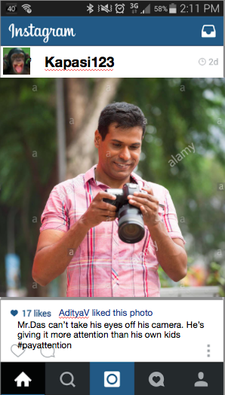
Mr. Kapasi’s story via Social Media Posts
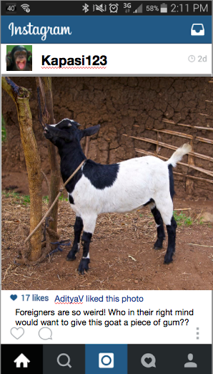
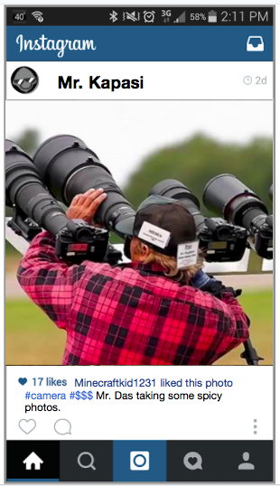
Here’s a full set of Kapasi123 Instagram Posts

~ ~ ~ ~ ~ ~ ~ ~ ~ ~ ~ ~ ~ ~ ~ ~

Mr. Kapasi’s Story via Scrapbook / Travel Journal / Memoir
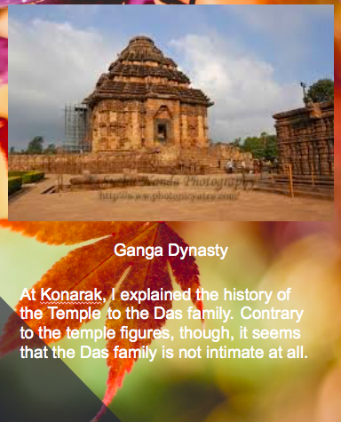
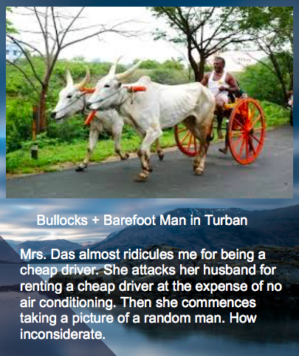

Want to focus on a different character?

Here’s a vacation scrapbook and a second one from Mrs. Das’s perspective. All Models.
DAY 3

Share Travelogues and Discussion Questions

- What do the monkeys represent / symbolize?

- Does Raj deserve to know the truth about Bobby?

- How might this day in his life ultimately change Mr. Kapasi’s relationship with his wife?

- The reader learns about Mr. Kapasi’s previous job as well as his current job. How do these jobs contribute to / suggest about the story’s overall meaning?

- What do you think is one overall message of this story?

- How does the title contribute to the message / story meaning? Look at page 50-1, 59, and 65-6 and the final moments of the story to glean meaning.

